Motivation:

In this example, I have several clients that use the same subset of a class interface. I want to extract that subset into its own explicit interface.

**Before Diagram:**

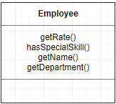

**Before:**

class TimeSheet

{

public Employee employee {get; private set;}

public double GetCharge (int days)

{

double result = employee.Rate * days;

if (employee.HasSpecialSkill)

{

result *= 1.05;

}

return result;

}

}

public class Employee

{

public int Rate {get; private set;}

public bool HasSpecialSkill {get; private set;}

}

**Mechanics:**

In this example we have this timesheet which depends on an employee and for a given span of days we will get a charge for that employee and then the **Employee class** of course just has the rate and whether or not that employee has a special skill for some business logic here but lets assume that this **Employee class** is part of a larger domain of shared functionality across the business and a lot of applications are going to use it this timesheet class on the other hand is part of a single application that just the payroll department uses well instead of seeing all of what an employee has to offer that it doesn’t really need. All it really need is just these **Rate** and **HasSpecialSkill** property of **Employee Class.** So instead of depending on an entire Employee, it could depend on just a subset of that functionality. So, let’s create that subset now and called this interface as **IBillable** and **Employee** can now implement **IBillable**. Then add these property Rate and **HasSpecialSkill** to **IBillable.** And renaming the **Employee** to **Resources.**

**After Diagram:**

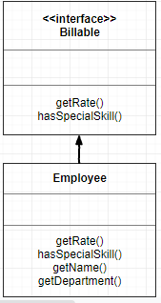

**After:**

class TimeSheet

{

public IBillable Resources {get; private set;}

public double GetCharge (int days)

{

double result = Resources.Rate * days;

if (Resources.HasSpecialSkill)

{

result *= 1.05;

}

return result;

}

}

interface IBillable

{

double Rate {get;}

bool HasSpecialSkill {get;}

}

public class Employee: IBillable

{

public double Rate {get; private set;}

public bool HasSpecialSkill {get; private set; }

}